Chapter 3
Japanese Spring Festival

3.1 Introduction
Spring in Japan is well-known for the full bloom of sakura (桜; cherry blossoms). Spring is a magical time in Tokyo. The sakura bloom in late march and everyone wants to be outside enjoying the good weather. If you are going to visit Tokyo for the cherry blossoms this spring, then you can’t miss some of these popular spring festivals.
Festivals, or matsuri (祭り), in Japan are common events. Almost every shrine celebrates their own festival. In Tokyo, there are well-known festivals that you must visit while you’re there in spring.These are the best festivals Tokyo’s Spring has to offer.

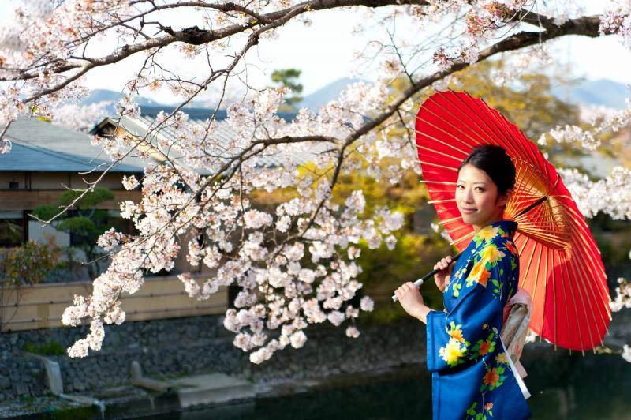

3.2 Sanja Matsuri (三社祭)
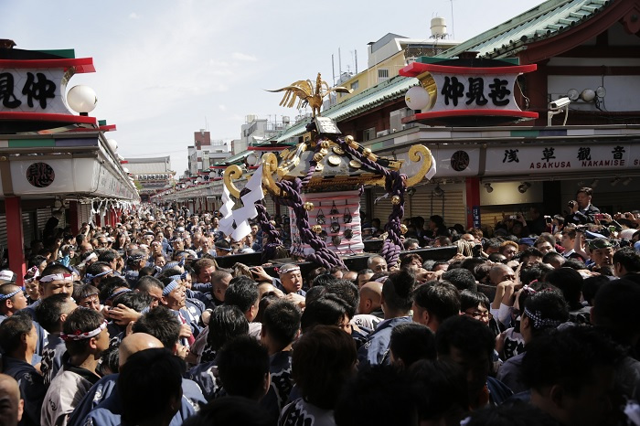
Fig-3.1 Sanja Matsuri Festival
Sanja Festival is celebrated every third Sunday of May at the Asakusa Shrine (浅草神社) and lasts for up to three days. This festival is one of the largest and wildest in Tokyo. The festival is held in honor of the three men who established Sensō-ji (浅草寺), Hinokuma Hamanari (檜前浜成命), Hinokuma Takenari (檜前竹成命), and Hajino Manakachi (土師真中知命).
This festival harbors at least 2 million people yearly. Why not be one of them and join the fun !!
http://www.sanja.jp/ This is the sanja festival website.
(This website can now be accessed only Japanese now.So,you should visit this website and get the taste of this festival if you are fluently in Japanese!!)

3.3 Kanda Matsuri (神田祭)
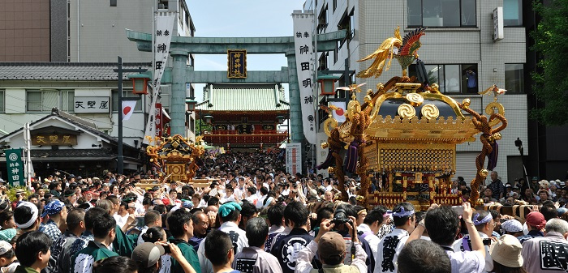
Fig-3.2 Kanda Festival

This is also one of the three major Shinto (神道) festivals in Tokyo. The Kanda Festival is held on the nearest Saturday and Sunday to May 15. Take note that this festival alternates with Sanno Matsuri (山王祭), so it is only held in odd-numbered years.
The main attractions you have to watch out for include the procession in central Tokyo on Saturday, and the parades of around a hundred mikoshi (portable shrines; 神輿) in many neighborhoods on Sunday.

3.4 Sanno Matsuri
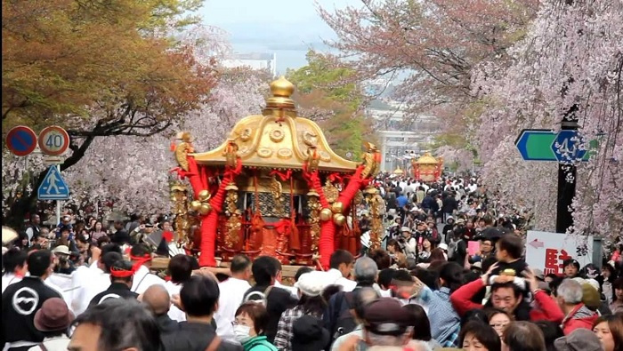
Fig-3.3 Sanno Matsuri Festival
The Sanno Festival is included in the three major festivals in Tokyo. It is celebrated in mid-June of even-numbered years, alternate to the Kanda Festival. The Hie Shrine (日枝神社) is the location for this festival. This festival dates back to the Edo-era (江戸時代) where it is related to the building of the Edo Castle (江戸城). The festival was originally intended to please the gods before the Spring construction season (construction of Edo Castle lasted 43 years).
Today, it's a quiet festival (as compared with rowdy festivals such as Sanja Matsuri). Around 500 people dressed in Edo-era imperial court attire embark on a incredibly long 25 kilometer parade through central Tokyo (it takes 9 hours). Needless to say, the festival isn't popular with local taxi drivers.
The main attraction in this festival is the parade that winds through central Tokyo. Don’t miss it in an even-numbered year!

3.5 Ueno Sakura Matsuri (上野桜祭り)
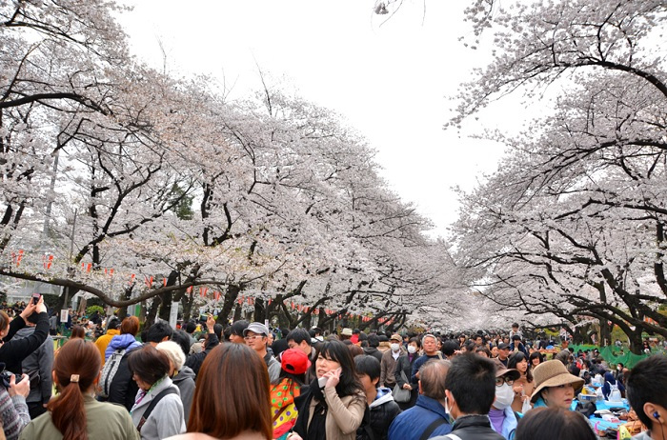
Fig-3.4 Ueno Sakura Matsuri Festival

Of course, what is spring without taking the time to view the cherry blossoms? Taking place at the end of March or early April, the Ueno (上野) Sakura Festival takes place in Ueno Park (上野公園).
The park is lined up with beautiful cherry blossom trees, which is why it is one of the best cherry blossom viewing spots in Tokyo, located in the center of the city.
A thousand lanterns are on display during the festival to give light to the park at night time. It is an awe-inspiring spectacle you shouldn’t miss.

3.6 Kurayami Matsuri (暗闇祭り)
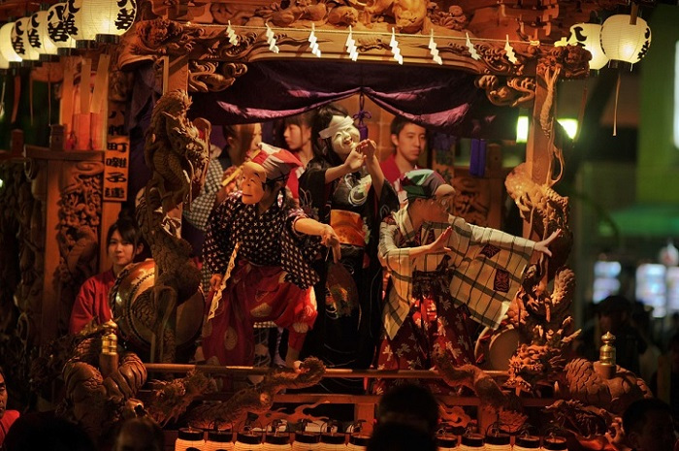
Fig-3.5 Kurayami Matsuri Festival
The Kurayami (暗闇; Darkness) Festival is one of the oldest festivals celebrated in Tokyo. Held at the Okunitama Shrine (大國魂神社) in Tokyo, the festival starts on April 30 until May 6. The Kurayami Matsuri (early May) has been held for almost 2000 years in Tokyo. Its name means "dark night" festival. Traditionally, houses in the neighborhood dim their lights on the evenings of the festival. The Kurayami Matsuri features mikoshi parades and music, horse riding and lantern hanging competitions. It is recommended to visit many times during this period but you could also just visit its main attractions.
This festival features portable shrines carried in the darkness and a large-scale plant fair where many gardeners come from all over Kanto (関東) Region to set up booths.

3.7 Special Mention: Fukagawa Matsuri (深川祭り)
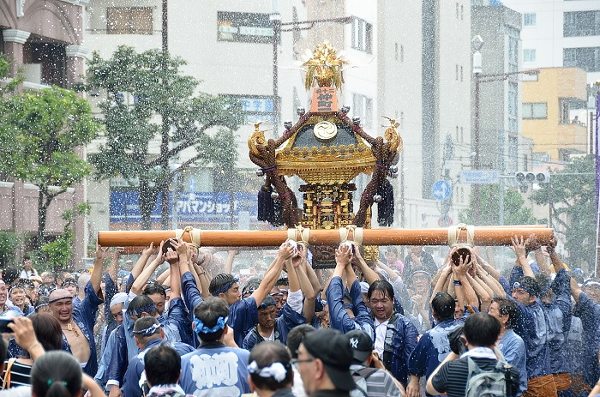
Fig-3.6 Fukagawa Matsuri Festival
Fukagawa Matsuri Festival is included in the three great Shinto Festivals in Tokyo together with Kanda Matsuri and Sanno Matsuri. It is held at the Tomioka Hachiman Shrine in Koto.
Because it is held in spring, it is a massive water fight festival where participants throw water on each other. It’s surely a great way to cool down!

3.8 Tokyo International Anime Fair
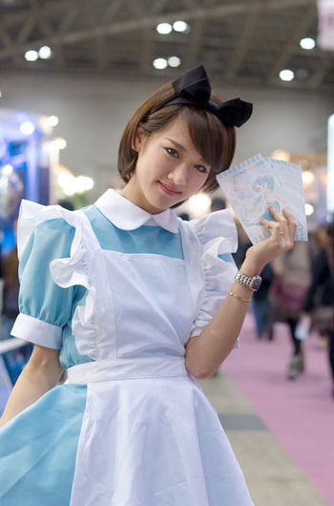
Fig-3.7 Tokyo International Anime Fair
The Tokyo International Anime Fair (end of March) is otaku paradise.It's the largest anime trade show in the world featuring 100s of booths and the Tokyo Anime Awards.
The event is four days. The first 2 days is open to industry insiders and press only. The last 2 days is open to the public.
For more information!!
You can check out on https://www.japan-talk.com/jt/new/tokyo-international-anime-fair :))

3.9 Kanamara Matsuri
The Kanamara Matsuri (Festival of the Steel Phallus) is a fertility festival held in early April at Kanayama shrine in Kawasaki.The event raises money for HIV / AIDS research.

If you will, by any chance, be in Tokyo in springtime then you must visit these festivals. You can enjoy the beautiful, cultural and sometimes slightly bizarre scenery, as well as any other festivities they have in store. Have fun this spring season!

